Using the video resource:

On launching the video resource, you will see the introductory screen with a series of tabs along the top:

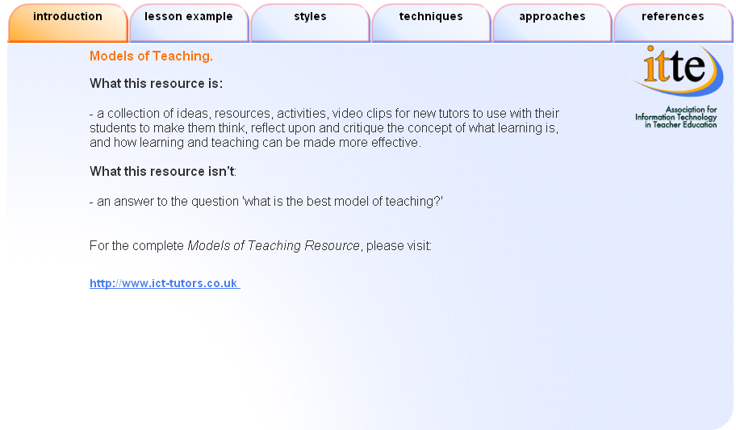

The Introduction tab is simply a commentary on what the resource is and isn’t and comprises a link back to the text based resource on the ict-tutors site.

The Lesson Example Tab

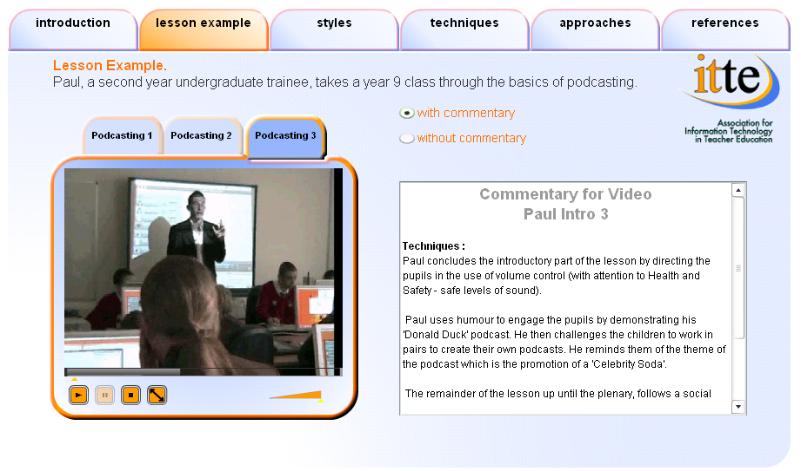

This section comprises a series of short video clips which may be used in a number of ways. For example, if the session is tutor-led, the tutor could switch the commentary feature off and identify the strategies present in the clips. Alternatively, the students can view the clips individually or in groups with the commentary on (or off) and identify further techniques for themselves.

Clip 1
New tutors could show the clip to the students and discuss the techniques observed (teacher presentation; direct interactive mode; outlining of teaching aims; demeanour; effective questioning techniques; engaging wallpaper on computer screens outlining session; verbal and non-verbal behaviours; ascertaining existing knowledge of class; explanation, setting scene and context; timing deadlines).

Clip 2
Clear direction (put hands up); pace of lesson; demonstration; use of whiteboard; visual aid tips guide on using the mac.

Clip 3
Using examples created earlier; scripts available for students to follow through or edit (suit learners who wish to move on faster and further).

Note:
On any video clip, use the button to display the video clip full screen.

Styles Tab

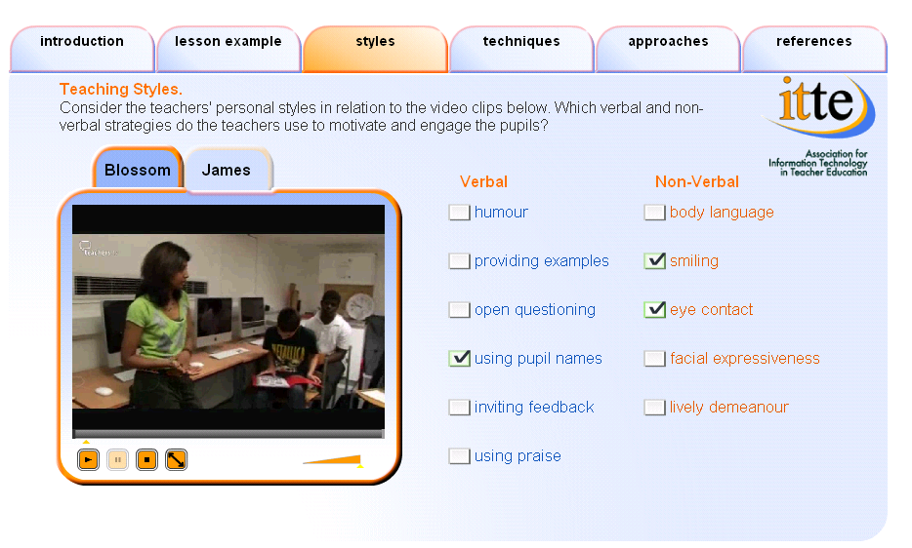

In these two examples, each teacher demonstrates a different teaching style. It is recommended that the new tutor guides students through a discussion on verbal and non-verbal behaviours, prior to using this activity. Each student should be encouraged to develop their own individual style and the tutor should take care not to be prescriptive here. The check list at the right of the screen provides some suggestions, but students may identify more verbal and non-verbal behaviours which can be noted on a flip chart or similar.

Through time, random video clips may populate this area. The Blossom and James examples just happen to be two that were considered useful at this stage. The framework/shell of the resource is structured to accommodate different clips.

Students could work with this resource in groups, individually or it may be tutor led for whole class discussion.

Techniques tab

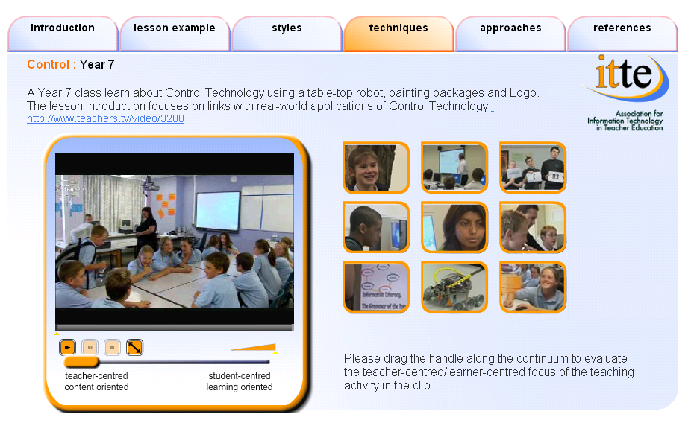

This section contains nine different video clips, extracted from Teachers’ TV. By hovering the mouse over each of the clips, a description of the content will appear.

By this time, students should be confident in analysing the clips for themselves. If this section is tutor led, the tutor may wish to pause the clips at various points and discuss with the students, the type of model they have been observing (and at which point in the continuum - teacher centred through to student centred). The slider at the bottom of the screen scrolls through a variety of transmission models. This feature is provided to facilitate discussion as there are no right or wrong answers. The resource is deliberately open ended, rather than prescriptive.

The Approaches Tab

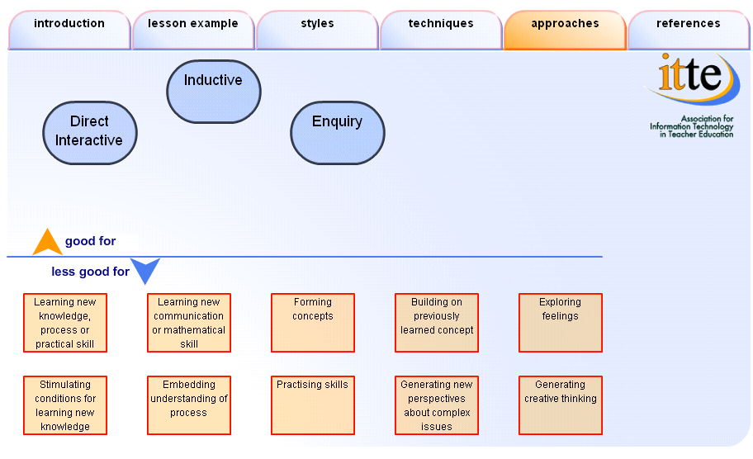

This part of the resource is derived from the DfES resources on models of teaching which examines three strategies (direct interactive; inductive; enquiry model) and encourages students to think about combining models for effective teaching. On clicking the Direct Interactive button, the corresponding boxes (DfES opinion) will move above the line into the “good for” area. In using this resource, students can see for themselves, that some models make reference to the same features. For example, the “Forming Concepts” button and the “Generating Creative Thinking” button apply to the Inductive model and the Enquiry model; whilst the “Learning new knowledge, process or practical skill” and the “Learning new communication or mathematical skill” appear only in the Direct Interactive model. Students can debate further, the DfES view on these models, as well as read the research citations contained in DfES units. Supplementary video clips are available on two DVDs accompanying the DfES resource.

